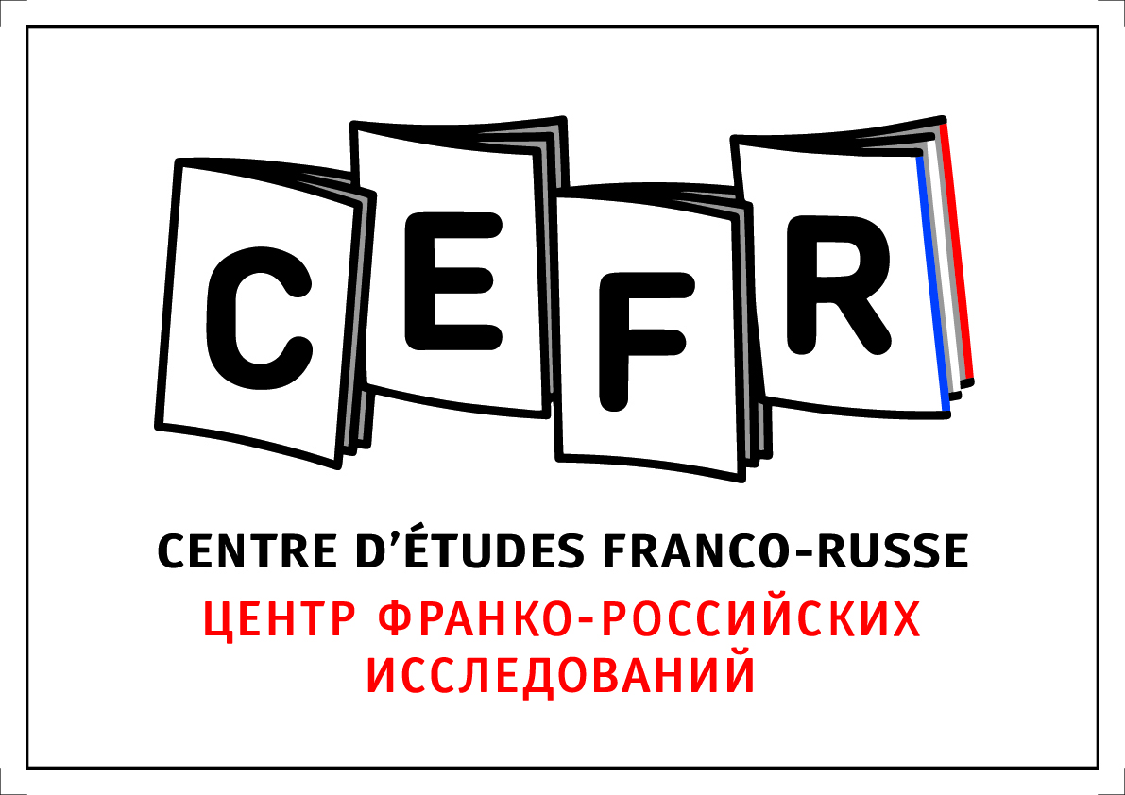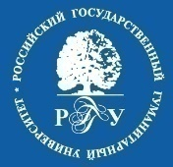

Family values and related ethical issues: an analysis of debates and mobilizations in Russia and in Europe

International workshop

November 14-15, 2019
Moscow, Russian State University for the Humanities, Moscow
Room 228 (Main building, 2nd floor)

Thursday, 14 November. 10:00 – 13.15

Introduction (15 min)

Section 1. Family values and medical technologies in Russia: a bioethical discourse

Nataliya Shok, Privolzhsky Research Medical University, Nizhny Novgorod

Biomedical ethics: Towards an interdisciplinary methodology (Russian Science Foundation project #18-78-10018, in Privolzhsky Research Medical University).

Mikhail Pershin, N. Pirogov Russian Medical Research University, Moscow.

Demographic message of the federal law “Foundations of healthcare in the Russian Federation”: factors and actors

Nadezhda Beliakova, Institute of World History, Russian Academy of Sciences, Moscow

Discourse of traditional values in Moscow centers of natural childbirth assistance.

Break (15 min)
Sergey Senchukov, First Moscow Ambulance Station

Ethical dilemma of death and dying: quality of life, family values and progress of medicine

Roman Tarabrin, I. Sechenov First Moscow State Medical University

Moral values of Orthodox faith vs. contemporary reproductive technologies – a false dilemma?

13.15 – 15.00. Lunch

Thursday, 15.00 – 17.30

Section 2. Orthodox Christianity and defending family in Russia

Kathy Rousselet, Centre d’Etudes et Recherches Internationales, Paris.
The cult of martyr family of the last Tsar and the family discourse in Russia
Caroline Hill, Uppsala University
Who is to blame, and what to do? Framing of abortion by Russian Orthodox clerics and activists
Dmitry Uzlaner, Russian Academy of national Economy and Public Administration, Moscow
Russian conservative agenda in the World congress of families
Sergey Vitiaev, Russian State University for the Humanities, Moscow
Who is afraid of the Father figure? The critics of the traditional family in Russia
18.30 Dinner

Friday, 15 November, 11.00 - 13.00
Section 3. Further confessional and country comparisons-1
Silvia Serrano, Sorbonne University, Paris
Soft mobilizations: “modesty” and the defense of traditional values in the Muslim context
Maria Viatchina, European University in St. Petersburg
Between economy and bioethics: the Halal certification of medical services in Tatarstan
Break (15 min.)
Oxana Kuropatkina, Center for the Study and Development of Intercultural Relations, Moscow
The Law of God and the laws of men: the role of the State strategies in constructing an ideal family model among Russian Orthodox traditionalists and Northern European Pietist Lutherans (Russian Science Foundation project #17-18-01194).
Tuomas Hynynen, University of Helsinki
The changing concept of family in the Evangelical Lutheran Church of Finland from 1960s to present day
13.00 – 14.00 Lunch
Friday, 14.00 - 16.00
Section 4. Further confessional and country comparisons-2
Igor Mikeshin, University of Helsinki.
"Marriage should be honored by all, and the marriage bed kept pure": Biblical family in the Russian Baptist Church
Lucian Cirlan, Ecole pratique des hautes études, Paris.
God’s activists. “Christian” civil society mobilization for traditional family in Romania
Ewa Maciejewska-Mroczek, University of Warsaw.
The state, the Catholic Church, and the process of family-making. The case of involuntary childlessness in Poland
Break (15 min)
16.15 – 17.00 Final discussion

The workshop was partly sponsored by the Centre d’Etudes Franco-Russes (Moscow). The event has also received partial funding from the European Research Council (ERC) under the European Union’s Horizon 2020 research and innovation programme (POSEC, grant agreement no. ERC-STG-2015-676804).

