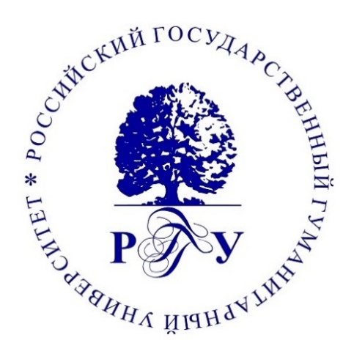
Russian State University for the Humanities | The Russian Academy of Sciences  Institute of World History
Faculty of International Relations, Political Sciences and Area Studies

Call for application for international conference

60 Years of the Cuban Missile Crisis:
History Lessons for the Present

Moscow, Russian State University for the Humanities, October 20 – 21, 2022
The following topics are up for discussion:
- The Cuban missile crisis in the context of Soviet-American relations;
- Imagology of the Cuban missile crisis;
- International reception of the Cuban missile crisis;
- The Cuban crisis as a historiographic problem;
- The reflection of the Cuban missile crisis in the literature and popular culture of the USSR/Russia and the USA;
- Lessons of the Cuban missile crisis for modern international relations.

The working languages of the conference are Russian and English. The conference is held in both offline and online formats. The registration fee is not charged. Conference committee does not reimburse the participants’ travel expenses.

Please send applications for participation in the conference before September 15, 2022 to Victoria Zhuravleva, Doctor of History, Head of the Department of American Studies, Vice Dean of the Faculty of IR, Political Sciences and Area studies via email at zhuravlevavic@mail.ru or to the RSUH Department of American Studies at dep_kai@rggu.ru. Selected materials are going to be published.

60 Years of the Cuban Missile Crisis:
History Lessons for the Present

October 20 – 21, 2022
Moscow, Russian State University for the Humanities

Application

Name
Organization
Job position
Contact Information:
phone
email
Title
Abstract (5-7 sentences)

